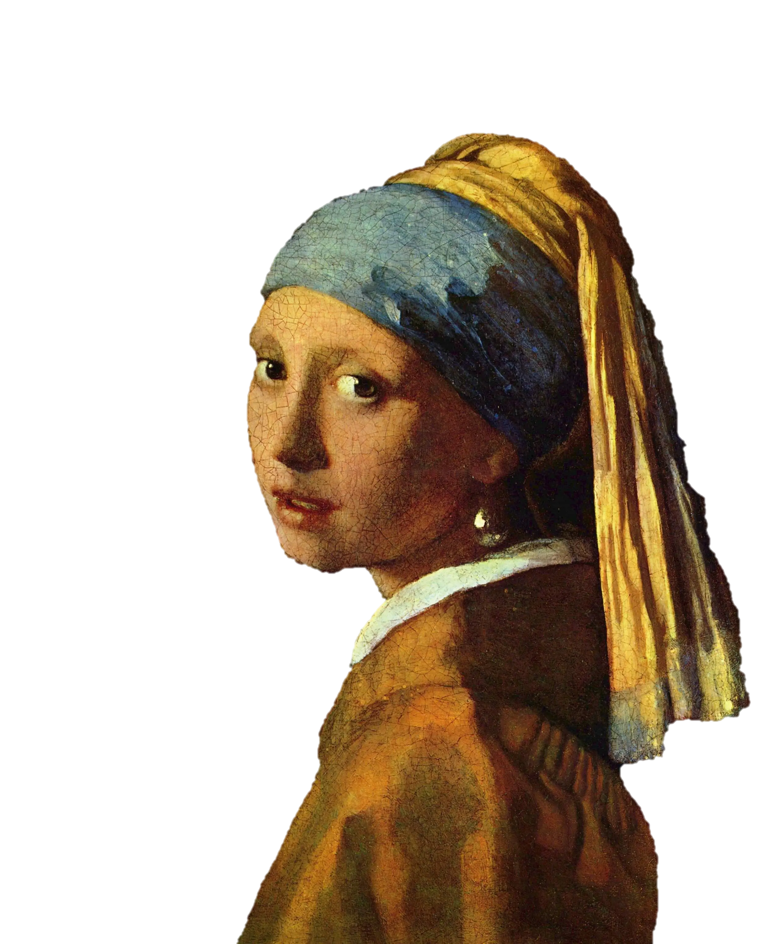**Painting Style Recognition**

**A university project for the**

**Artificial Intelligence course**

**Developed by:**

> [Alireza Nobakht](https://github.com/alirezanobakht2004)

> [Arshia Abedin](https://github.com/ArshiaABD10)

> [Moien Talebi](https://www.linkedin.com/in/moien-talebi-9755192b4/)

**Supervisor: Dr. Pishgoo**

**In KNTU university of tech**



# Introduction: Artificial Intelligence in Art

Art has consistently evolved in response to technological innovation, reflecting the intellectual and cultural progress of human societies. With the rapid advancement of Artificial Intelligence (AI), computational methods have become increasingly significant in analyzing and understanding artistic works. Among these methods, Deep Learning has emerged as a powerful approach for automatically recognizing and classifying painting styles.

Painting style recognition is a complex task due to the abstract and high-dimensional nature of visual art. Artistic styles are defined by subtle characteristics such as brush strokes, color palettes, composition patterns, texture, and visual rhythm. These features are often difficult to formalize using traditional rule-based or handcrafted feature extraction methods. As a result, conventional machine learning approaches may struggle to achieve high accuracy and generalization across diverse artistic movements.

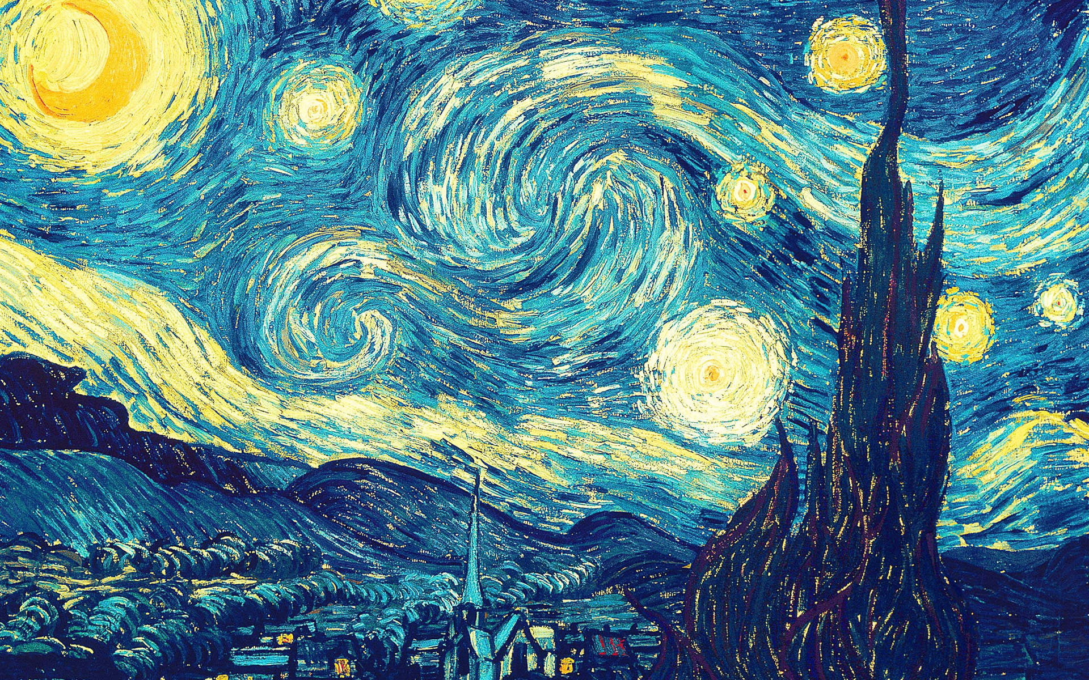

Deep Learning addresses these challenges by enabling models to automatically learn hierarchical representations directly from image data. Convolutional Neural Networks (CNNs) have demonstrated strong performance in image classification tasks, including artistic style recognition. By training on large datasets of labeled paintings, CNN-based models can identify complex visual patterns and distinguish between styles such as Impressionism, Cubism, Baroque, Surrealism, and others with significant accuracy.

However, several challenges remain in this domain. The availability and quality of labeled art datasets can significantly affect model performance. Variations in image resolution, lighting conditions, digitization quality, and overlapping stylistic characteristics between art movements may introduce classification ambiguity. Additionally, deep models require substantial computational resources and large amounts of training data to achieve optimal results.

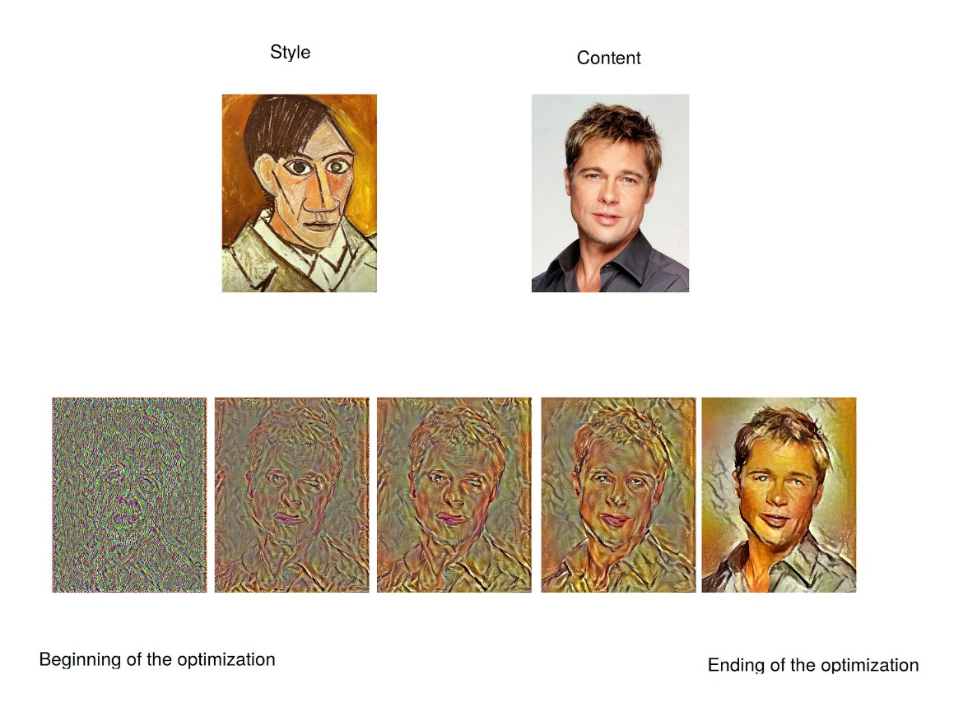

Despite these challenges, the application of Deep Learning in painting style recognition offers substantial benefits. It contributes to automated art analysis, digital archiving, educational tools, museum curation systems, and recommendation engines in online art platforms. Furthermore, it provides researchers with quantitative methods to study stylistic evolution and artistic influence across historical periods.

# Project Introduction and Overview

This project focuses on **painting style recognition using Deep Learning**, aiming to automatically identify the artistic style of a given painting image. The task is formulated as a **multi-class image classification problem**, where each input image is assigned to one of several predefined art movements, such as Impressionism, Cubism, Renaissance, Surrealism, and others.

The core objective of the project is to design, train, and evaluate a deep learning–based model capable of learning discriminative visual features that characterize different painting styles. Due to the abstract nature of art, stylistic elements such as brush strokes, color composition, texture, and structural patterns are often subtle and highly variable, which makes this problem particularly challenging for traditional image processing and rule-based methods.

To address these challenges, the project employs **Convolutional Neural Networks (CNNs)**, which are well-suited for visual pattern recognition. The model is trained on the **WikiArt dataset**, a large-scale and widely used art dataset containing paintings categorized by artistic style. Given the original dataset’s large size and class imbalance, data curation and sampling strategies are applied to create a balanced and manageable subset suitable for efficient training and evaluation.

This project is structured as an academic Artificial Intelligence course project and is divided into multiple phases. The first phase establishes a baseline CNN model, defines the data preprocessing pipeline, and evaluates initial performance. Subsequent phases are designed to explore more advanced architectures and techniques, such as transfer learning with deep pre-trained models, to improve classification accuracy and robustness.

Overall, this work demonstrates the practical application of **Deep Learning in computational art analysis**, highlighting both its effectiveness and its challenges in recognizing complex artistic styles from visual data.

# Workflow

This project is divided into two main phases: **theoretical** and **practical**.

In the first phase, the focus was on data preparation, analysis, and designing the overall modeling strategy. In the second phase, the proposed design was implemented, tested, and systematically improved to enhance performance and evaluation results.

Dividing the project into two structured phases provides several advantages. By separating the **theoretical planning stage** from the **practical implementation stage**, the development process becomes more organized, goal-oriented, and analytically grounded.

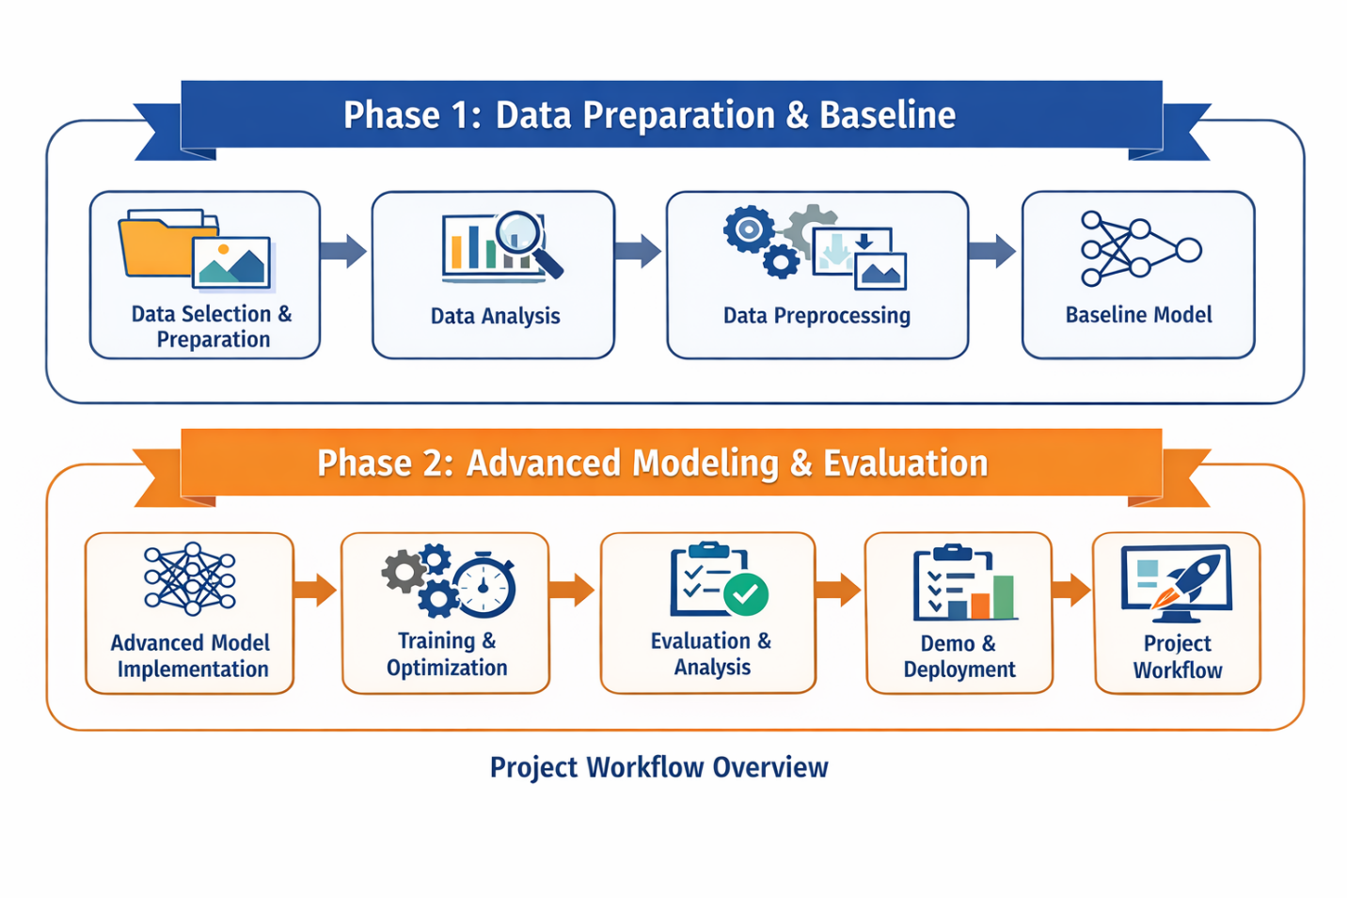

In the first phase, careful data preparation and strategy design reduce the risk of architectural or experimental mistakes during implementation. This structured planning ensures that model development is based on informed decisions rather than trial-and-error. In the second phase, the focus shifts to execution, evaluation, and systematic improvement, allowing performance optimization based on measurable results.

In the following sections, a detailed explanation of each phase will be presented, including the specific steps performed and the results obtained throughout the project.

Phase #1

Documentation

**Data Preparation and Baseline Model**

# **#1.1 Dataset Overview**

The WikiArt dataset was used as the primary data source for this project. The dataset contains paintings categorized into 27 different artistic styles.

Due to class imbalance in the original dataset, an under-sampling strategy was applied. For each style, 1000 images were randomly selected to create a balanced dataset suitable for training.

The final processed dataset characteristics are:

* Number of classes: 27
* Images per class: 1000
* Total images (after balancing): approximately 10,000
* Data split strategy: Stratified split
* Training set: 70%
* Validation set: 15%
* Test set: 15%

# **#1.2 Class Distribution After Balancing**

The following figure shows the class distribution after applying the sampling strategy.

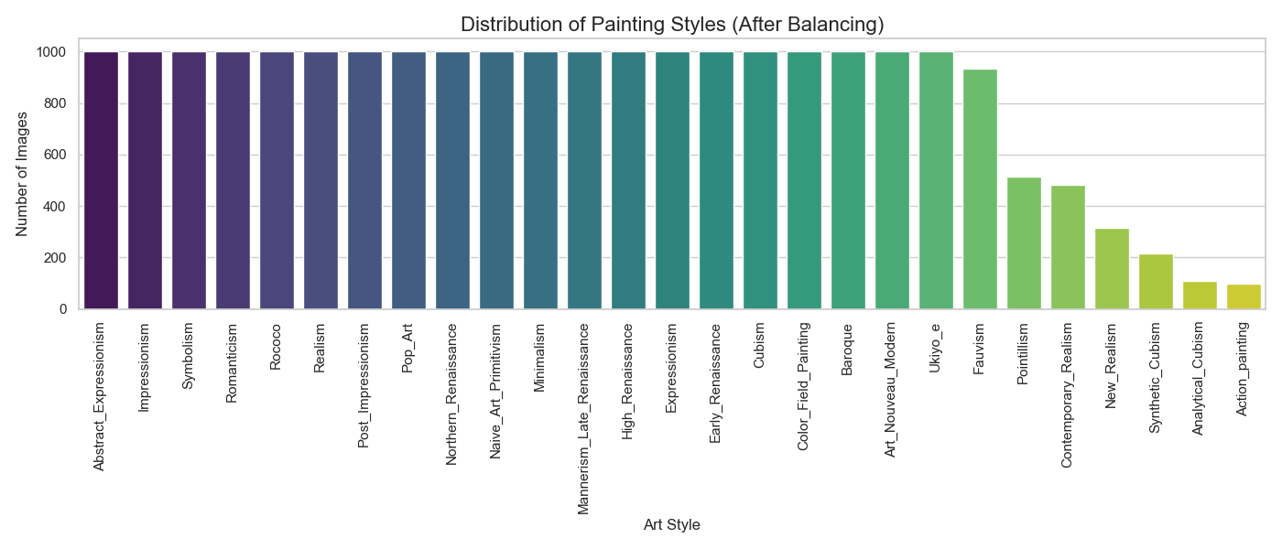

The distribution confirms that all classes are balanced, reducing the risk of model bias toward majority classes.

# **#** **2.1 Image Dimension Analysis**

An analysis of image dimensions was performed to understand variability across the dataset.

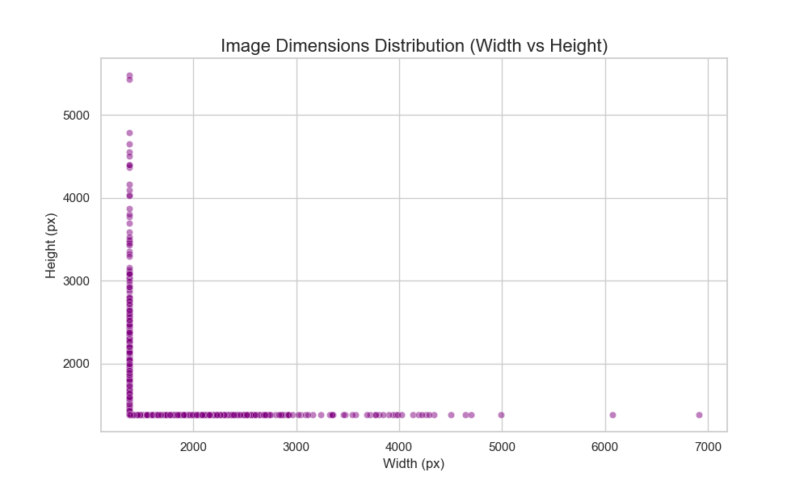

The results indicate significant variation in image width and height, which justifies the need for resizing during preprocessing.

# **#2.2 Brightness Distribution**

The brightness distribution of images was analyzed to detect potential lighting inconsistencies.

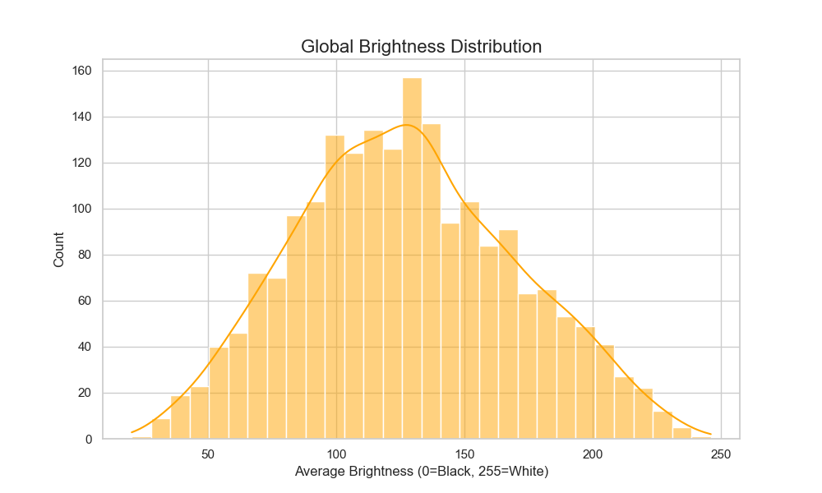

The histogram shows a near-normal distribution of brightness values, indicating that no extreme contrast correction was required.

# **#** **3.1 Data Transformation Steps**

All images were processed through a standardized preprocessing pipeline before being fed into the neural network.

The applied transformations include:

* Resize to 224×224 pixels
* Random Rotation (±15 degrees)
* Random Resized Crop
* Horizontal Flip (training set only)
* Normalization using ImageNet mean and standard deviation

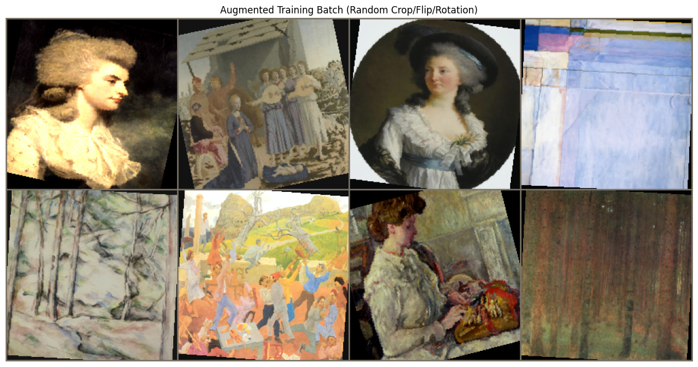

# 3.2 Augmentation Samples

To improve generalization and robustness, data augmentation was applied to the training set.

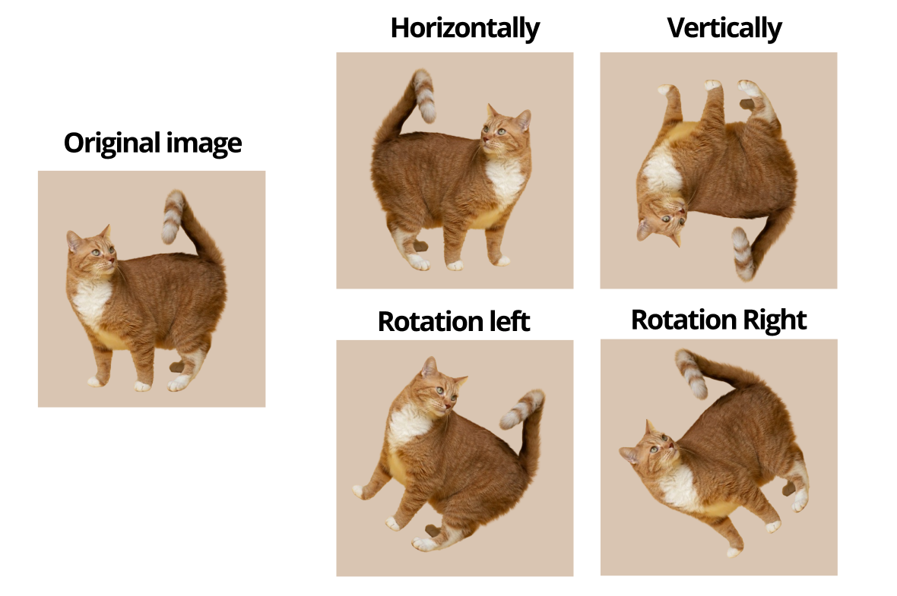

The augmented samples demonstrate variability introduced into the dataset to prevent overfitting.

# 4.1 Model Architecture

A SimpleCNN model was designed as the baseline architecture.

The architecture consists of:

* Four convolutional layers
* Batch normalization layers
* Max pooling layers
* Two fully connected layers
* Dropout layer (rate = 0.5)

This baseline model serves as a performance benchmark for future improvements.